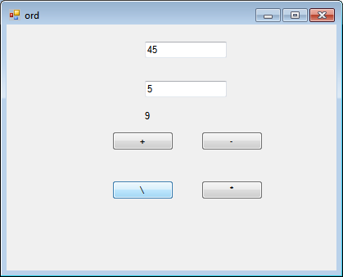

Public Class Form1

Private Sub myProc(ByVal s As Char)

Dim no1 = CInt(TextBox1.Text)

Dim no2 = CInt(TextBox2.Text)

Dim res As Integer

Select Case s

Case "+"c

res = CInt(TextBox1.Text) + CInt(TextBox2.Text)

Case "-"c

res = CInt(TextBox1.Text) - CInt(TextBox2.Text)

Case "\"c

res = CInt(TextBox1.Text) \ CInt(TextBox2.Text)

Case "*"c

res = CInt(TextBox1.Text) * CInt(TextBox2.Text)

End Select

lblResult.Text = res.ToString

End Sub

Private Sub btnAdd_Click(ByVal sender As System.Object, ByVal e As System.EventArgs) Handles btnAdd.Click

myProc(btnAdd.Text)

End Sub

Private Sub btnSub_Click(ByVal sender As System.Object, ByVal e As System.EventArgs) Handles btnSub.Click

myProc(btnSub.Text)

End Sub

Private Sub btnDiv_Click(ByVal sender As System.Object, ByVal e As System.EventArgs) Handles btnDiv.Click

myProc(btnDiv.Text)

End Sub

Private Sub btnMul_Click(ByVal sender As System.Object, ByVal e As System.EventArgs) Handles btnMul.Click

myProc(btnMul.Text)

End Sub

Private Sub Form1_Load(ByVal sender As System.Object, ByVal e As System.EventArgs) Handles MyBase.Load

End Sub

End Class